**Practical Work Experience and Portfolio Building**

**Evidence Reporting Document**

* **Introduction**

*The main goal of this document is to keep track of the practical hands-on work experience and lab challenges you will complete throughout the program. By doing so, at the end of the program, you will have a great portfolio that you can use for evidence of your practical skills, and you can also come back for review whenever needed. This evidence is essential in the long run and keeps you on track with the time you will spend on your career upgrade process. These notes will also play a vital role in identifying the skills and tools to reflect on your marketing materials like your CV/resume or LinkedIn Page.*

* **General Details**

**Date: 17 May 2024**

**Your Name: LOK HIM TAM (Himson)**

**Email-address:** himsom0528@gmail.com

**Name of the Challenge:** Manage Shared Access Signature Keys [Guided]

**Access Details (URL or source):** AZ500

**Details of the Challenge:**

In this lab I have working following exercise:

* Created a storage account and container.
  + Create an Azure storage account named sa41229513 by using the **corp-datalod41229513** resource group and locally-redundant storage (LRS).
  + Create a container named images in the **sa41229513** storage account.
  + Upload any image file on your computer to the **images** container as a **64 KB** block blob by using an authentication type of **Account key**.
* Generated a SAS key and verified that it grants access to the container.
  + Generate a SAS key for the blob file
  + I recorded the blob SAS URL.
  + I can access the blob by using the recorded SAS URL.
* Created an access policy.
  + Create an access policy for the **images** container
  + Generate a SAS key for the blob file that you uploaded by using the BLOB-read-list access policy.
  + i created an access policy.
  + i generated and recorded a SAS key using the access policy.
  + i can access the blob file by using the recorded SAS URI.
* Revoked an access policy, and then verified that the policy was revoked.
  + Delete the **BLOB-read-list** access policy for the **images** container to revoke the access policy.
  + 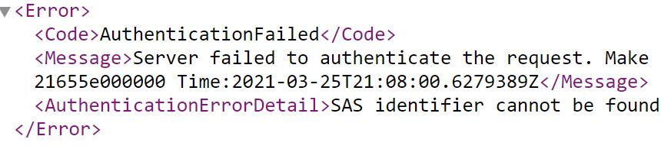

**Lab Topology**

Generate a SAS key for the blob file that you uploaded by using the values in the following table. For any property that is not specified, use the default value.

| **Property** | **Value** |
| --- | --- |
| Signing method | **Account key** |
| Signing key | **Key 1** |
| Permissions | **Read** |
| Allowed protocols | **HTTPS only** |

Create an access policy for the **images** container by using the values in the following table. For any property that is not specified, use the default value.

| **Property** | **Value** |
| --- | --- |
| Identifier | BLOB-read-list |
| Permissions | **Read** and **List** |
| Start time | The current date at **12:00 AM** |
| Expiry time | Tomorrow's date at **12:00 AM** |

* **Challenge Details**

**Before starting the challenge:**

1. Be sure that the lab is in the scope of your niche.
2. You have enough time to solve the full lab or have a proper plan to solve a part of it and complete the remaining sections later.
3. Try to build a good learning environment with less distraction for at least 30 minutes to an hour.

**After completing the challenge:**

1. Were you able to finish the lab? Did you need extra time? Was the lab relevant to your expectations? Did you need additional help to solve the lab?

* Yes I am able to finish the lab within 45 mins. It is relevant to my expectations. And I can finish it without additional help.

1. Write down your learning outcomes, skills you developed or improved and the tools you used in this challenge.

*(You may use the keywords listed in the lab details or add your own skills that you think you acquired.)*

* I learnt how to create a storage account and container.
* And then Upload any image file on your computer to the **images** container as a **64 KB** block blob by using an authentication type of **Account key**.
* I learnt how to generated a SAS key and verified that it grants access to the container.
  + Generate a SAS key for the blob file
  + I recorded the blob SAS URL.
  + I can access the blob by using the recorded SAS URL.
* I learn how to created an access policy.
  + Create an access policy for the **images** container
  + Generate a SAS key for the blob file that you uploaded by using the BLOB-read-list access policy.
  + I created an access policy.
  + I generated and recorded a SAS key using the access policy.
  + I can access the blob file by using the recorded SAS URI.
* Revoked an access policy, and then verified that the policy was revoked.
  + I learn how to delete the **BLOB-read-list** access policy for the **images** container to revoke the access policy, and I can see I cannot access the image

1. Prepare a self-reflection and reporting video using any screen recording tool (like Loom) and share the link.

*(The report may include but is not limited to your thoughts about the problem solved, difficulties encountered, any notes to discuss with your peers, anything to ask the mentors and last but not least how it may help you in your ideal job. Please prepare the summary in a way that you are presenting this to your managers and colleagues in your ideal workplace)*

**URL:** [**https://www.loom.com/share/cec3c84e93a34000817be1922936dba6?sid=dd1f0088-8666-4c68-817b-380958e99b9a**](https://www.loom.com/share/cec3c84e93a34000817be1922936dba6?sid=dd1f0088-8666-4c68-817b-380958e99b9a)